**Disclaimer**

This ETC/CME Working Paper has not been published and therefore no reference can be made to it in any other formal or published document or document meant for publication. This document has not been subjected to any formal review by the European Environment Agency (EEA) or EEA’s member countries. It does not represent the formal views of the EEA and its ETC/CME.

ETC/CME Working paper

European Topic Centre on Climate   
change mitigation and energy

Boeretang 200

B-2400 Mol, Belgium

Tel.: +32 14 33 59 77

Email: etccme@vito.be

**Meta information on this ETC/CME working paper**

**Task reference**

|  |  |  |  |  |
| --- | --- | --- | --- | --- |
| **AP** | **Task #** | **Task Title** | **ETC Task leader** | **EEA contact Persons** |
| 2019 | 1.3.8.3 | Methodologies to assess GHG emissions savings from RES technologies | Evert Bouman | Mihai Tomescu |

**Type, titles and series number of report**

|  | **Working paper** |
| --- | --- |
| **Title:** |  |
| **Sub title:** |  |
| **Number: (*)** |  |

**Authors**

|  | **Name** | **Institute** | **Name** | **Institute** |
| --- | --- | --- | --- | --- |
| **Lead Author:** |  |  |  |  |
| **Co-authors:** |  |  |  |  |
|  |  |  |  |  |
|  |  |  |  |  |
|  |  |  |  |  |
| **Reviewer(s)** |  |  |  |  |
|  |  |  |  |  |

**Status & Deadlines**

|  |  |  |
| --- | --- | --- |
| **(**)** | **Planned deadline according Action Plan** | **Actual date of delivery** |
| “Draft deliverables for approval by EEA” | <dd.mm.yyyy> |  |
| “Final deliverables approved by EEA” | <dd.mm.yyyy> |  |
| Publication on ETC/CME website | <dd.mm.yyyy> |  |

**(**)** Deliver to Eionet Forum IG of the ETC/CME (<https://forum.eionet.europa.eu/etc-cme-consortium/library>) in its appropriate pre-defined task-subfolder.

**Document history**

| **Version** | **Authors/ Reviewers** | **Date** | **Description/Comments** |
| --- | --- | --- | --- |
|  |  |  |  |
|  |  |  |  |
|  |  |  |  |
|  |  |  |  |
|  |  |  |  |
|  |  |  |  |
|  |  |  |  |

Contents

Acknowledgements 5

Executive Summary 6

1 Introduction 7

2 Methodology 8

2.1 Life Cycle Assessment 8

2.2 Scale-up to annual impacts and counter factual scenario 11

2.3 Data sources 11

2.4 Sectoral coverage 12

3 Results 13

3.1 Findings regarding GHG emissions 13

3.1.1 Life cycle GHG emissions intensities for individual electricity production technologies. 13

3.1.2 Development of life cycle GHG emissions in the EU-28 14

3.1.3 Avoided GHG emissions relative to 2005 16

3.2 Other impact indicators 18

4 Discussion 20

4.1 Methodological uncertainty 20

4.2 Comparison with other avoided emissions studies 20

4.3 Recommendations for future updates 20

5 Conclusions 22

References 23

Zotero references. 24

Annex 1 Implemented emissions factors for fuel combustion 25

Annex 2 Life cycle assessment contribution analyses 26

Brown coal 26

Hard coal 26

Oil 27

Natural gas 27

Nuclear 28

Hydro power 28

Offshore wind 29

Onshore wind 29

Solar thermal 30

Photovoltaic 30

# Acknowledgements

This report was prepared by the European Topic Centre for Climate Change Mitigation and Energy (ETC/CME) under task 1.3.8.3 on “Methodologies to assess greenhouse gas emissions savings from renewable energy source technologies”. The author would like to express thanks to the project manager for the European Environment Agency (EEA), Mihai Tomescu, for the comments and technical input to this work. In addition, Filippo Capizzi from the Flemish Institute for Technological Research (VITO) is acknowledged for his aid and explanations with respect to the result data from the Short Assessment of Renewable Energy Sources (SHARES).

# Executive Summary

# Introduction

The generation of electricity and heat contributes approximately 23.3% to annual anthropogenic greenhouse gas (GHG) emissions of the EU28 (EEA 2019) and energy system transformation towards the use of renewable and low-carbon energy sources is a key part of climate change mitigation strategies. For the European Union, this is reflected by the headline targets for climate change mitigation, energy efficiency and renewable energy for 2020 and 2030 in the Energy Union strategy (EC 2015), along with minimum targets for electricity interconnection (10 % by 2020 and 15 % by 2030). Essentially, following the adoption of the first Renewable Energy Directive (EU 2009), the use of renewable energy sources (RES) in the European energy system has increased significantly over the past decades. In 2017, GHG emissions from the public electricity and heat sector in the EU28 constituted a share of 23.3% of total GHG emissions without land use, land use change and forestry (LULUCF), down from approximately 27% in 2012 (EEA 2019). This decrease can largely be attributed to the increased use of renewable electricity and heating services (EEA 2017, 2018). Nonetheless, the public heat and electricity sector remains the largest single source of GHG emissions in the EU.

As part of its ‘Renewable energy in Europe’ reports, the European Environment Agency (EEA) estimates the effects of increased renewable energy deployment on greenhouse gas emissions in the European energy system (EEA 2015, EEA 2018). This is done by comparing the actual growth in renewable energy use across the EU since 2005 against a counterfactual scenario that assumes this growth would have been satisfied by non-renewable (essentially fossil) energy sources (EEA 2015). The resulting difference between actual emissions and the counterfactual scenario can subsequently be interpreted as gross avoided GHG emissions[1]. The latest report shows that gross avoided fossil fuel use in 2016 amounts to 143 Mtoe, with corresponding gross avoided greenhouse gas emissions amounting to 460 Mt CO2, of which 71 % (328 Mt CO2) can be attributed to the electricity sector. Cumulative avoided emissions for the electricity sector in the period 2005-2016 amount to 1903 Mt CO2 (EEA 2018).

While the GHG emissions from non-combustion renewable electricity generation, such as photovoltaic (PV) power and wind power, are virtually zero during operation, the construction of renewable power generation components and plants is both material and energy intensive. Power generation from renewable sources is therefore not emission, nor impact, free. A benchmark study published by the United Nations Environment Programme’s International Resource Panel (IRP) compared the emissions and environmental impacts per unit electricity generation over the entire cradle-to-gate[2] life cycle for a variety of fossil and renewable power generation technologies (UNEP 2016). All direct and indirect emissions associated with construction, operation and decommissioning of power plants and their key components were included in the study. Direct emissions refer here to those emissions associated with an activity, such as construction of the power plants, whereas indirect emissions comprise all emissions occurring along the value chains that support the activity in question, such as the production and transport of steel and cement, or the extraction and transport of fossil fuels.

The IRP study found that renewable power plants require larger amounts of metals and other minerals per unit electricity generated, but generally have consistently lower environmental impacts than fossil generators in nearly all impact categories investigated. However, emissions and impacts associated with renewable electricity generation are non-zero and there is variety between the different types of renewable electricity generation technologies in terms of their environmental impact potential. This is why energy efficiency improvements and energy savings need to be placed at the heart of the energy transition. It is therefore also of interest to shed light on the avoided environmental impacts due to the increased use of renewable energy sources in the EU electricity system from a life cycle perspective.

Going beyond GHG emissions, the main aim of this report is to provide an estimate for the avoided environmental impacts, from a life cycle perspective, due to the increased utilisation of RES in the electricity supply across the EU28, relative to the benchmark year 2005. To this extent, a bottom-up life cycle assessment (LCA) model is employed. The life cycle perspective adds a systemic overview of the potential environmental impacts associated with electricity generation over time. Four impact categories are selected for calculation: GHG emissions, land occupation, human health, and external costs.

The report consists of five Chapters: the **introduction** (Chapter 1); the **methodology** (Chapter 2), outlining shortly key methodological choices and data sources; the **results** (Chapter 3), which describes life cycle (LC) impact intensities for the individual electricity generation technologies, develops LC impact estimates for electricity generation in Europe since 2005 and estimates the avoided LC impacts relative to 2005; the **discussion** (Chapter 4), setting results of this report in the context of previous publications; and **conclusions** (Chapter 5) summarizing the key findings.

# Methodology

This Chapter shortly outlines the methodology employed in this ETC/CME report. A fuller presentation of the employed methods, equations, and assumptions is presented in the separate ETC/CME report: *“A life-cycle perspective on benefits of renewable electricity generation – Methodology and assumptions. “*.

## Life Cycle Assessment

In order to quantify the avoided GHG emissions over time, a bottom-up life cycle assessment (LCA) model has been employed. LCA is a tool to estimate the potential environmental impacts of a product, process or service over its life cycle. It is used to assist in environmental decision making, supporting policies and strategies, because it can help identify unforeseen consequences – so-called ‘environmental problem shifting’. In this way, it can contribute to a better management of environmental trade-offs. Problem shifting can occur when a proposed solution to reduce environmental impacts due to emissions from an activity results in increased environmental impacts of the same or of different types, due to other emissions upstream or downstream in the value chain. LCA results can deliver insight from two different perspectives.

1. Firstly, inventory analysis attributes pollutant emissions of singular environmental stressors, such as CO2 emissions, to a product or service.
2. Secondly, impact assessment aggregates groups of stressors into impact categories through calculation of an impact indicator. The classical example is aggregation of GHG emissions into the Global Warming Potential expressed in CO2-equivalent.

**The life cycle perspective and capacity of LCA to aggregate many environmental emissions into impact categories makes LCA well suited for the comparative assessment of technologies that vary widely, but ultimately provide the same service.**

A typical LCA study consists of four phases: (i) goal and scope definition, (ii) construction of the life cycle inventory, (iii) calculation of life cycle impact assessment results, and (iv) an interpretation phase that runs in parallel as LCA is a data intensive and often iterative process (ISO 2006). The life cycle inventory (LCI) is a collection of process descriptions detailing the input and outputs to and from economy and environment. Often, LCA studies rely on extensive use of an LCI database and only a limited number of processes is modelled. The process model, coupled to the LCI database, results in the quantification of emissions to the environment per functional unit. As such, the output of the LCI can be viewed as life cycle emissions intensity of the product, process or service under investigation. In the life cycle impact assessment (LCIA) phase an impact assessment method is used to aggregate the environmental emissions into impact indicators representative for a variety of impact categories, such as climate change, (freshwater) ecotoxicity potential, or acidification potential. Various LCIA methods are available to LCA practitioners. This aggregation allows for a meaningful comparison between different environmental emissions as the environmental fate, exposure and effect of singular emissions may vary greatly.

In order to calculate the avoided GHG emissions and other impact indicators for the EU28, the set of life cycle inventories (LCIs) used for the IRP study was chosen as the starting point, as they enable comparative analysis in single analytical structure, where the same background data is used for any common processes (Hertwich, Gibon et al. 2015). These inventories were supplemented with LCIs from various other sources as the IRP study does not contain all electricity technologies. The individual LCIs act as basis for calculating the impact intensities to deliver 1 MWh electricity to the grid. Each of the inventories can be represented in the simplified generic structure presented in Figure 1. Modelled are the construction of power plant infrastructure, power plant operation and power plant decommissioning. For the fossil and biomass combustion technologies, in addition, fuel extraction and transport are modelled. Each of the processes is connected to the background databases for any other requirements, e.g. steel for power plant infrastructure, or diesel for operating construction machinery. Note that while environmental emissions and or resource use may occur at every process, these are not depicted in Figure 1.

.

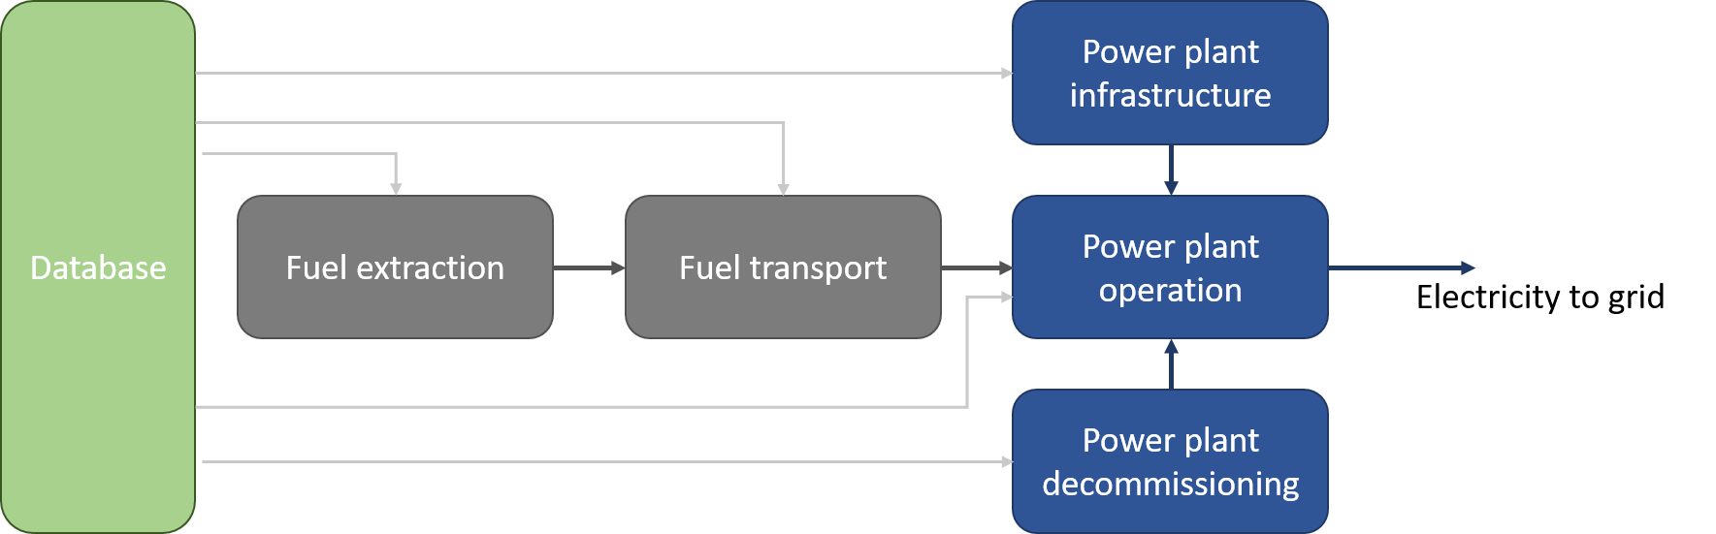

Figure 1: Generic scheme for life cycle inventory of electricity production.

The individual LCIs acts as a base model and a set of key parameters, described in sections 2.2.1 and 2.2.2 of the accompanying methodology report (Bouman 2019), are adapted to reflect changes in annual emissions as well as differences between Member States. For the fuel combusting technologies, the power plant operation in the base models is adjusted to reflect the energy-equivalent fuel input as specified by the European energy balances reported by Eurostat[3]. In addition, emissions during operation are scaled according to the energy input using emissions factors based on the guidelines underpinning the national GHG emissions inventories (IPCC 2006) and the air pollutant emissions inventory guidebook 2016 (EMEP and EEA 2016). Note that for CO2, these are the same emissions factors as specified in annex VI of Commission Regulation 601/2012. The emission factors are listed in Annex 1 of this report.

For the non-combustion renewable electricity production technologies, parameters were scaled based on installed capacity and annual output, by calculating annual capacity factors. In this context, a capacity factor reflects the (hypothetical) percentage of hours in a year that the power plant is operating at its rated capacity. In the case of solar thermal, photovoltaic and wind power, the latter is set equal to the peak power rating. The capacity factors for renewables typically lie between 10% and 25%, as seasonal and diurnal variations lead to power production often well below the peak power rating. Capacity factors are an important parameter in life cycle calculations, as the environmental impacts associated with the construction of the power plant infrastructure need to be divided over the total amount of electricity produced during the power plant lifetime, in order to obtain the impact contribution of infrastructure per unit electricity generation. In this report, capacity factors per renewable technology, Member State and year were calculated from data on annual electricity production and installed capacity, obtained from the detailed Eurostat Short Assessment of Renewable Energy Sources (SHARES) results.[4]

For nuclear power generation, the LCI was kept constant over time and across Member States.

## Scale-up to annual impacts and counter factual scenario

For each year and Member State, the LCIs for the individual technologies result in an impact intensity per unit electricity produced. By multiplying with total electricity production for each technology, the total life cycle impact associated with electricity per year and Member State is calculated.

These environmental impacts are subsequently compared to the counterfactual scenario. The counterfactual scenario is constructed by maintaining the share of renewable electricity production constant at 2005 level. Any additional electricity production in the subsequent years is assumed to be produced from fossil generators, according to the relative shares in 2005.

## Sectoral coverage

An overview of the modelled technologies is given in Table 1.

Table 1: Overview of technologies in the model

|  |  |  |
| --- | --- | --- |
| **Energy resource** | **Assumed conversion technology** | **Reference** |
| *Brown coal* | Subcritical coal power plant | UNEP, 2016 |
| *Hard coal* | Supercritical coal power plant | UNEP, 2016 |
| *Oil* | Oil fired power plant | Ecoinvent v3.6 |
| *Natural gas* | Natural gas combined cycle power plant | UNEP, 2016 |
| *Nuclear* | Pressure water reactor nuclear power plant | Ecoinvent v3.6 |
| *Hydro* | Hydro power from dam | UNEP, 2016 |
| *Offshore wind* | Offshore wind power | UNEP, 2016 |
| *Onshore wind* | Onshore wind power | UNEP, 2016 |
| *Solar thermal* | Trough based concentrating solar power plant | UNEP, 2016 |
| *PV* | Poly-Si rooftop mounted photovoltaic power module | UNEP, 2016 |
| *Biomass* | Wood chip combustion in combined heat and power generator | Ecoinvent v3.6 |
| *Biogas* | Biogas combustion in combined heat and power generator | Ecoinvent v3.6 |

The data available in the detailed SHARES results as well as the fossil fuel energy balance data by Eurostat distinguish more technologies than the life cycle inventory models used in this report. For example, the combustion of peat or the production of electricity from oil shale is not covered by the inventories described in Table 1. In addition, a significant amount of heat and power is co-generated in either main activity producer or autoproducer plants. As a result, the bottom-up approach taken in this report does not cover all electricity production sectors in the EU28. Figure 2 shows the percentage of total electricity production covered by the model. For further information on the correspondence between the technology classification in this report and the respective source data we refer to section 2.3 of the methodology and assumptions report (Bouman 2019).

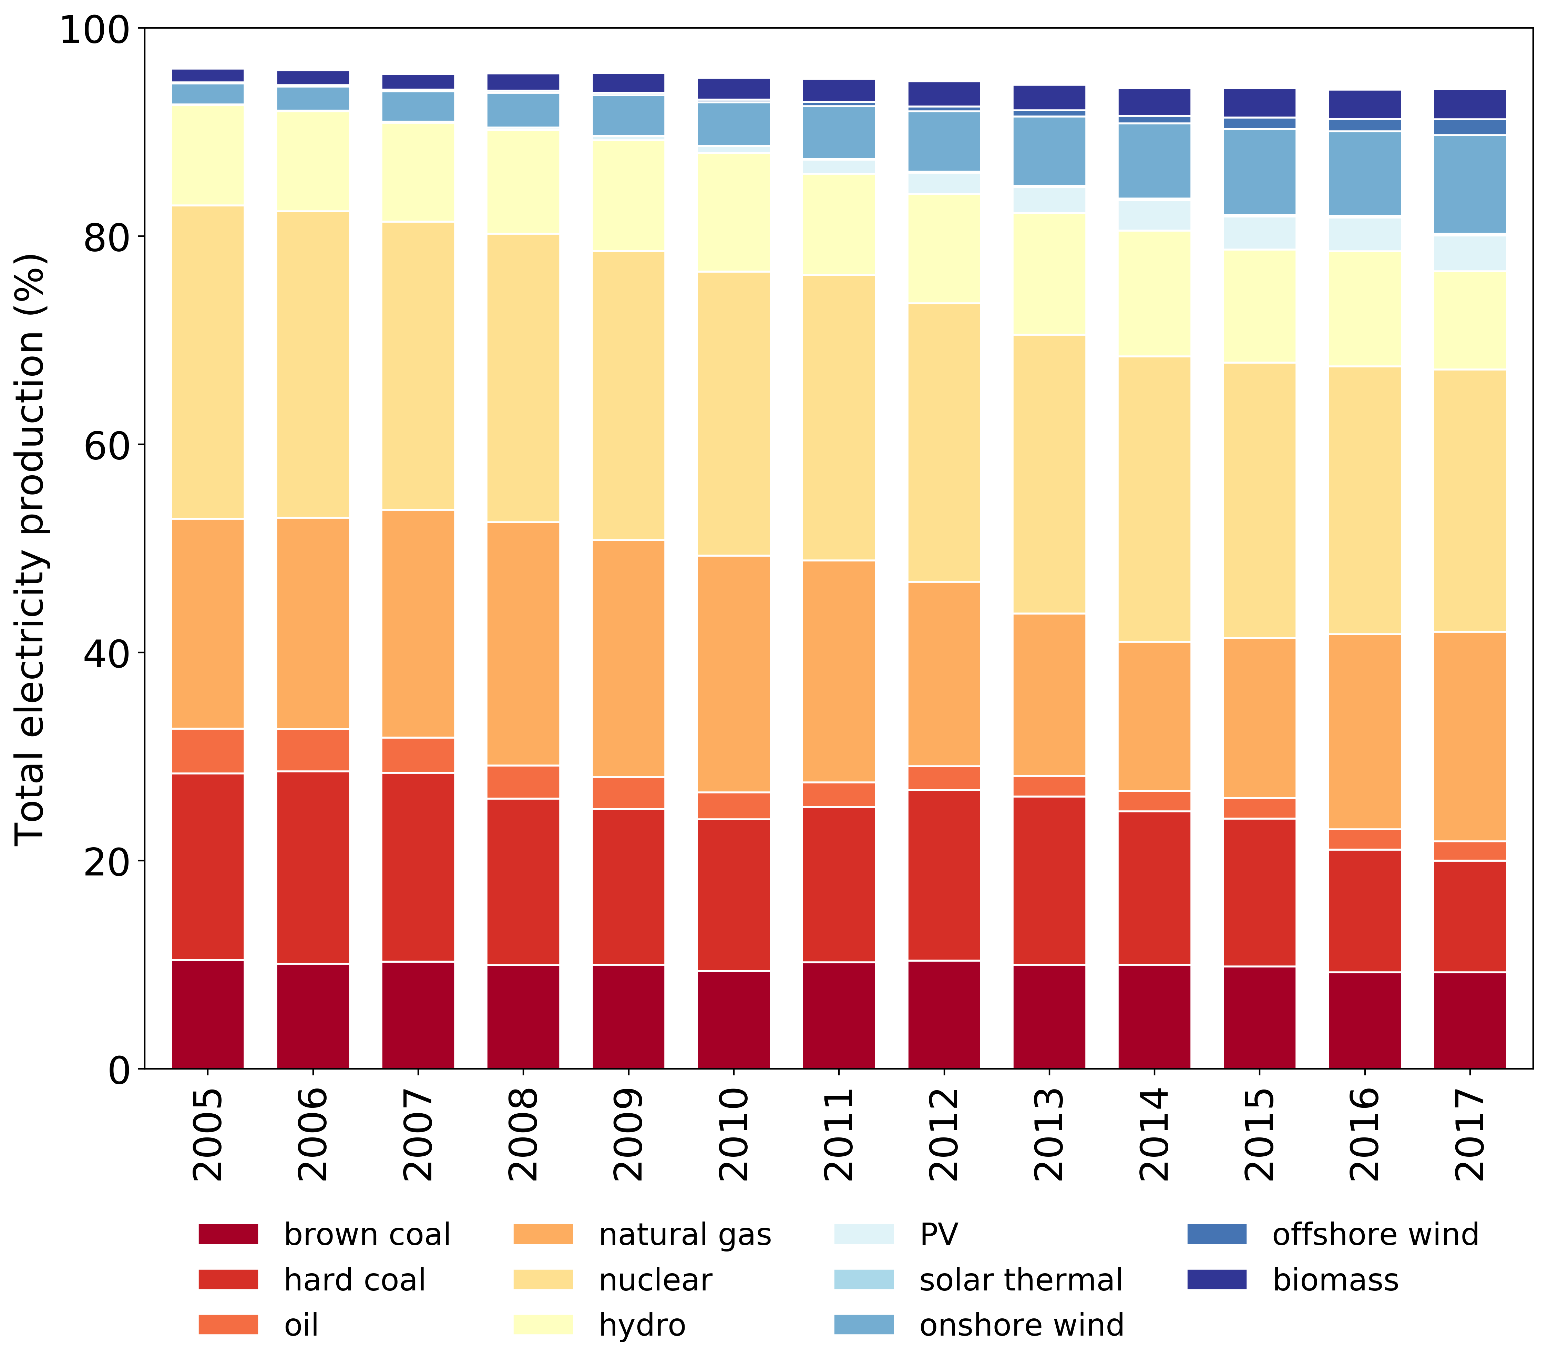

Figure 2: Percentage of total electricity production covered by the life cycle inventories. Note that electricity production from fuels such as oil shale or peat is not represented in the model. Data sources: Eurostat nrg_bal_c and SHARES.

# Results

In this Chapter the results of the analysis are described. To get an overview of the individual impact intensity for electricity per electricity production technology section 3.1 present the life cycle GHG emissions intensities. Section 3.2 continues with the impact trends in the EU28 for the impact categories climate change, land occupation, human health and external costs. In section 3.3 the results for the counterfactual scenario and avoided life cycle impacts are presented.

## Life cycle GHG emissions intensities for individual electricity production technologies.

As a starting point for analysis, the life cycle impact assessment results were calculated for each of the individual life cycle inventories. The resulting average EU28 GHG emissions intensities are presented in

Figure 3 as an example of the four impact categories. The height of the bars indicates the mean GHG emission intensity in the period 2005-2017, with results for individual years shown as scatter. Electricity production from brown coal combustion has the highest life cycle GHG emissions intensity, followed by electricity production from hard coal, oil and natural gas combustion. Of the renewable technologies, photovoltaic generation has the highest GHG emission intensity, possibly due to the high amount of energy required for producing the poly-Si material, as well as due to generally low capacity factors which increase the infrastructure related impacts per unit production.

A similar effect is observed for solar thermal energy. Some very high emissions intensities were calculated for the years 2007-2009. A significant increase in newly installed capacity was observed for these years, leading to temporary low capacity factors since not all new capacity was operational for the full year.

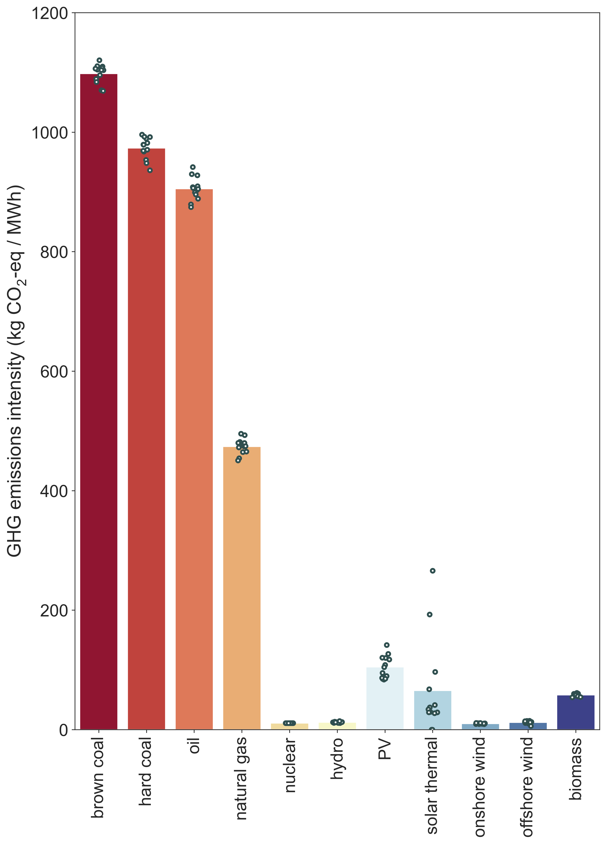Table 2: GHG emission intensity values.

|  |  |  |
| --- | --- | --- |
| **Energy resource** | **Value** | **Unit** |
| *Brown coal combustion* | 1098 | kg CO2-eq/MWh |
| *Hard coal combustion* | 974 | kg CO2-eq/MWh |
| *Oil combustion* | 905 | kg CO2-eq/MWh |
| *Natural gas combustion* | 474 | kg CO2-eq/MWh |
| *Nuclear* | 11 | kg CO2-eq/MWh |
| *Hydro* | 13 | kg CO2-eq/MWh |
| *Offshore wind* | 12 | kg CO2-eq/MWh |
| *Onshore wind* | 10 | kg CO2-eq/MWh |
| *Solar thermal* | 65 | kg CO2-eq/MWh |
| *PV* | 105 | kg CO2-eq/MWh |

Figure 3: GHG intensities in kg CO2-eq / MWh.

## Development of life cycle impacts associated with electricity production in the EU-28

The share of RES in the European electricity mix increased steadily in the period 2015. Annual gross electricity production in TWh is shown in Figure 4, and individual country mixes for 2005 and 2017 are shown in Figure 5. At a European level, there is a clear reduction in the use of hard coal and oil for electricity generation. Increases in renewable generation since 2005 seem to come mainly from increases in onshore wind and solar PV production.

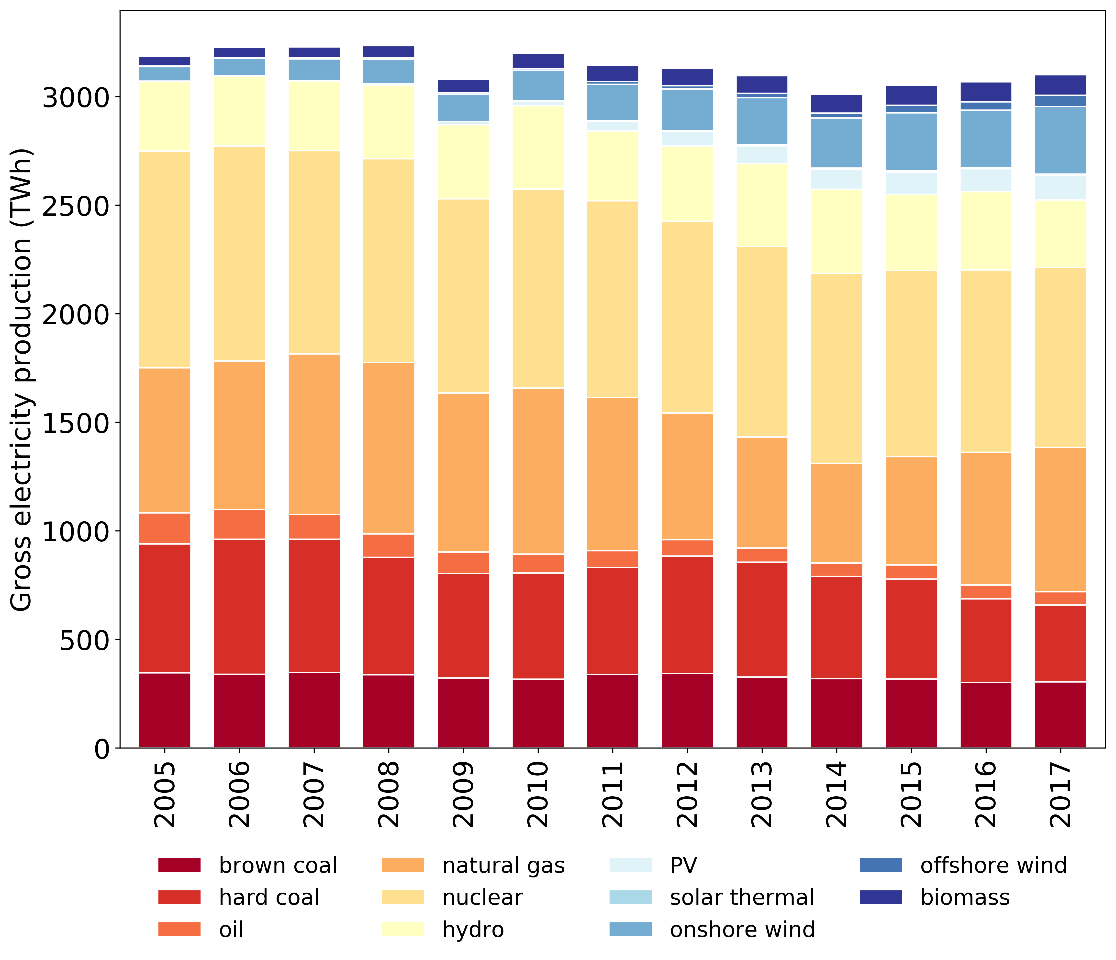

Figure 4: Gross electricity production by technology for the EU28. Data source:Eurostat nrg_bal_c and SHARES.

Similar trends can be seen clearly also at the Member State level. Whereas in 2005 few Member States had significant wind power production, virtually all Member States have solar photovoltaic or wind power production in 2017, reflecting the rapid construction of new PV and wind power plants. Note that in Figure 5 Member States are ranked from low to high shares of fossil fuels in their electricity mix and that the Member State order differs between the top and bottom panels. Countries that have made significant increases in renewable electricity production are Luxembourg and Denmark. In addition, Estonia appears to have increased its electricity production from renewable sources, but it should be noted that electricity from oil shale, which accounts for a significant amount in Estonia’s electricity mix, is not included on the fossil fuel side, since an equivalent LCI dataset was not available from the IRP data.

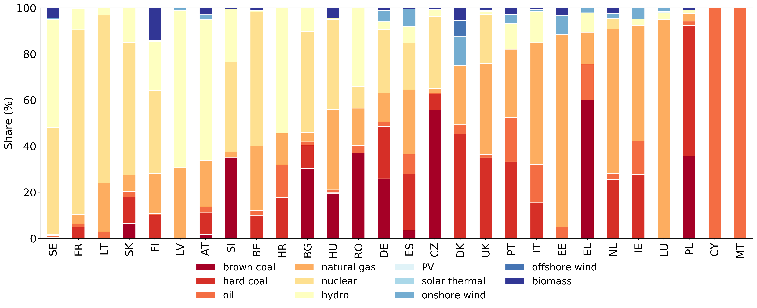

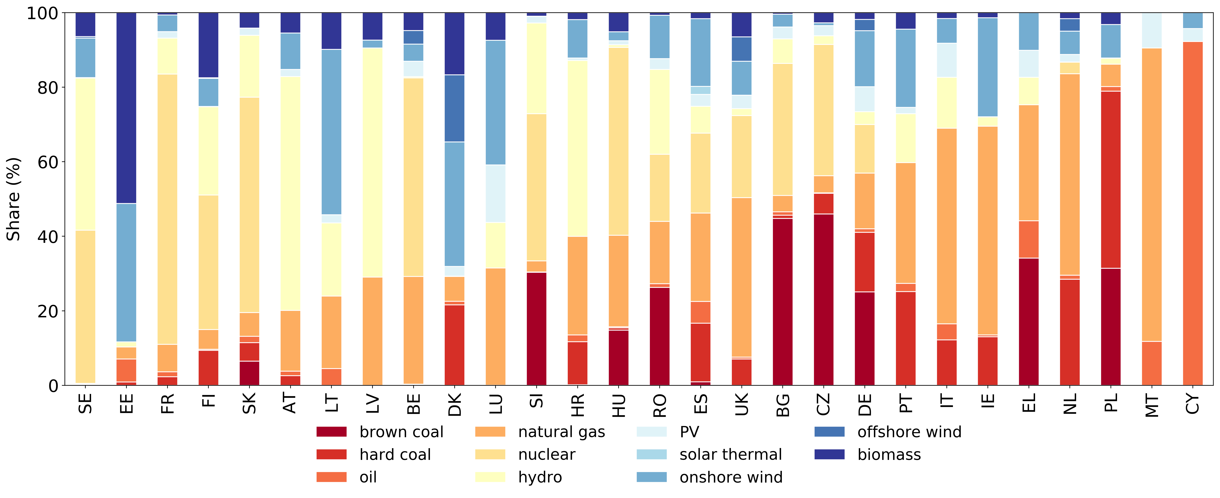

Figure 5: Electricity production by technology and member state for the year 2005 (top) and 2017 (bottom). Data source: Eurostat nrg_bal_c and SHARES.

Multiplying the electricity production per technology, Member State and year with life cycle GHG emissions intensities and summing up the results over all technologies and Member States results in the annual life cycle impacts associated with European electricity production, shown in Figure 6.

Figure 6 depicts the annual life cycle impacts of electricity production in the EU28 for four different impact categories and broken down by resource. The impact categories presented are climate change, land occupation, human health and external costs, expressed in respectively Mt CO2-eq GHG emissions, km2a, Disability Adjusted Life Years (DALY) and billion EUR2016. Not surprisingly, life cycle impacts are dominated by electricity production from brown and hard coal combustion for electricity generation, followed by emissions from natural gas and oil combustion. Despite the life cycle impacts from electricity produced from RES being non-zero, these are hardly visible and contribute less only a few to the total life cycle impacts of the EU-28 power mix for climate change, human health and external costs. Only in the case of land occupation, we observe an increase in land occupation potential. The contribution is not associated with the space the actual PV modules occupy, but rather the indirect and direct land occupation associated with the production of polycrystalline silicon and assembly of the PV modules. Note that in a life cycle model, the emissions and resource use may be dispersed geographically (to account for global value chains) and time (to account for the life cycle). Consequentially estimated potential impacts, while attributed to European electricity production, may partially occur elsewhere. Whereas hard coal combustion was responsible for more than 40% of all life cycle GHG emissions in the 2005 EU power mix, the significant reduction of hard coal in the electricity mix has led to more equal shares of hard coal, brown coal and natural gas in life cycle GHG emissions in the EU power mix by 2017. This trend is less apparent for the other impact categories as the impact intensity of electricity production from natural gas for land are typically lower than for electricity production from coal combustion.

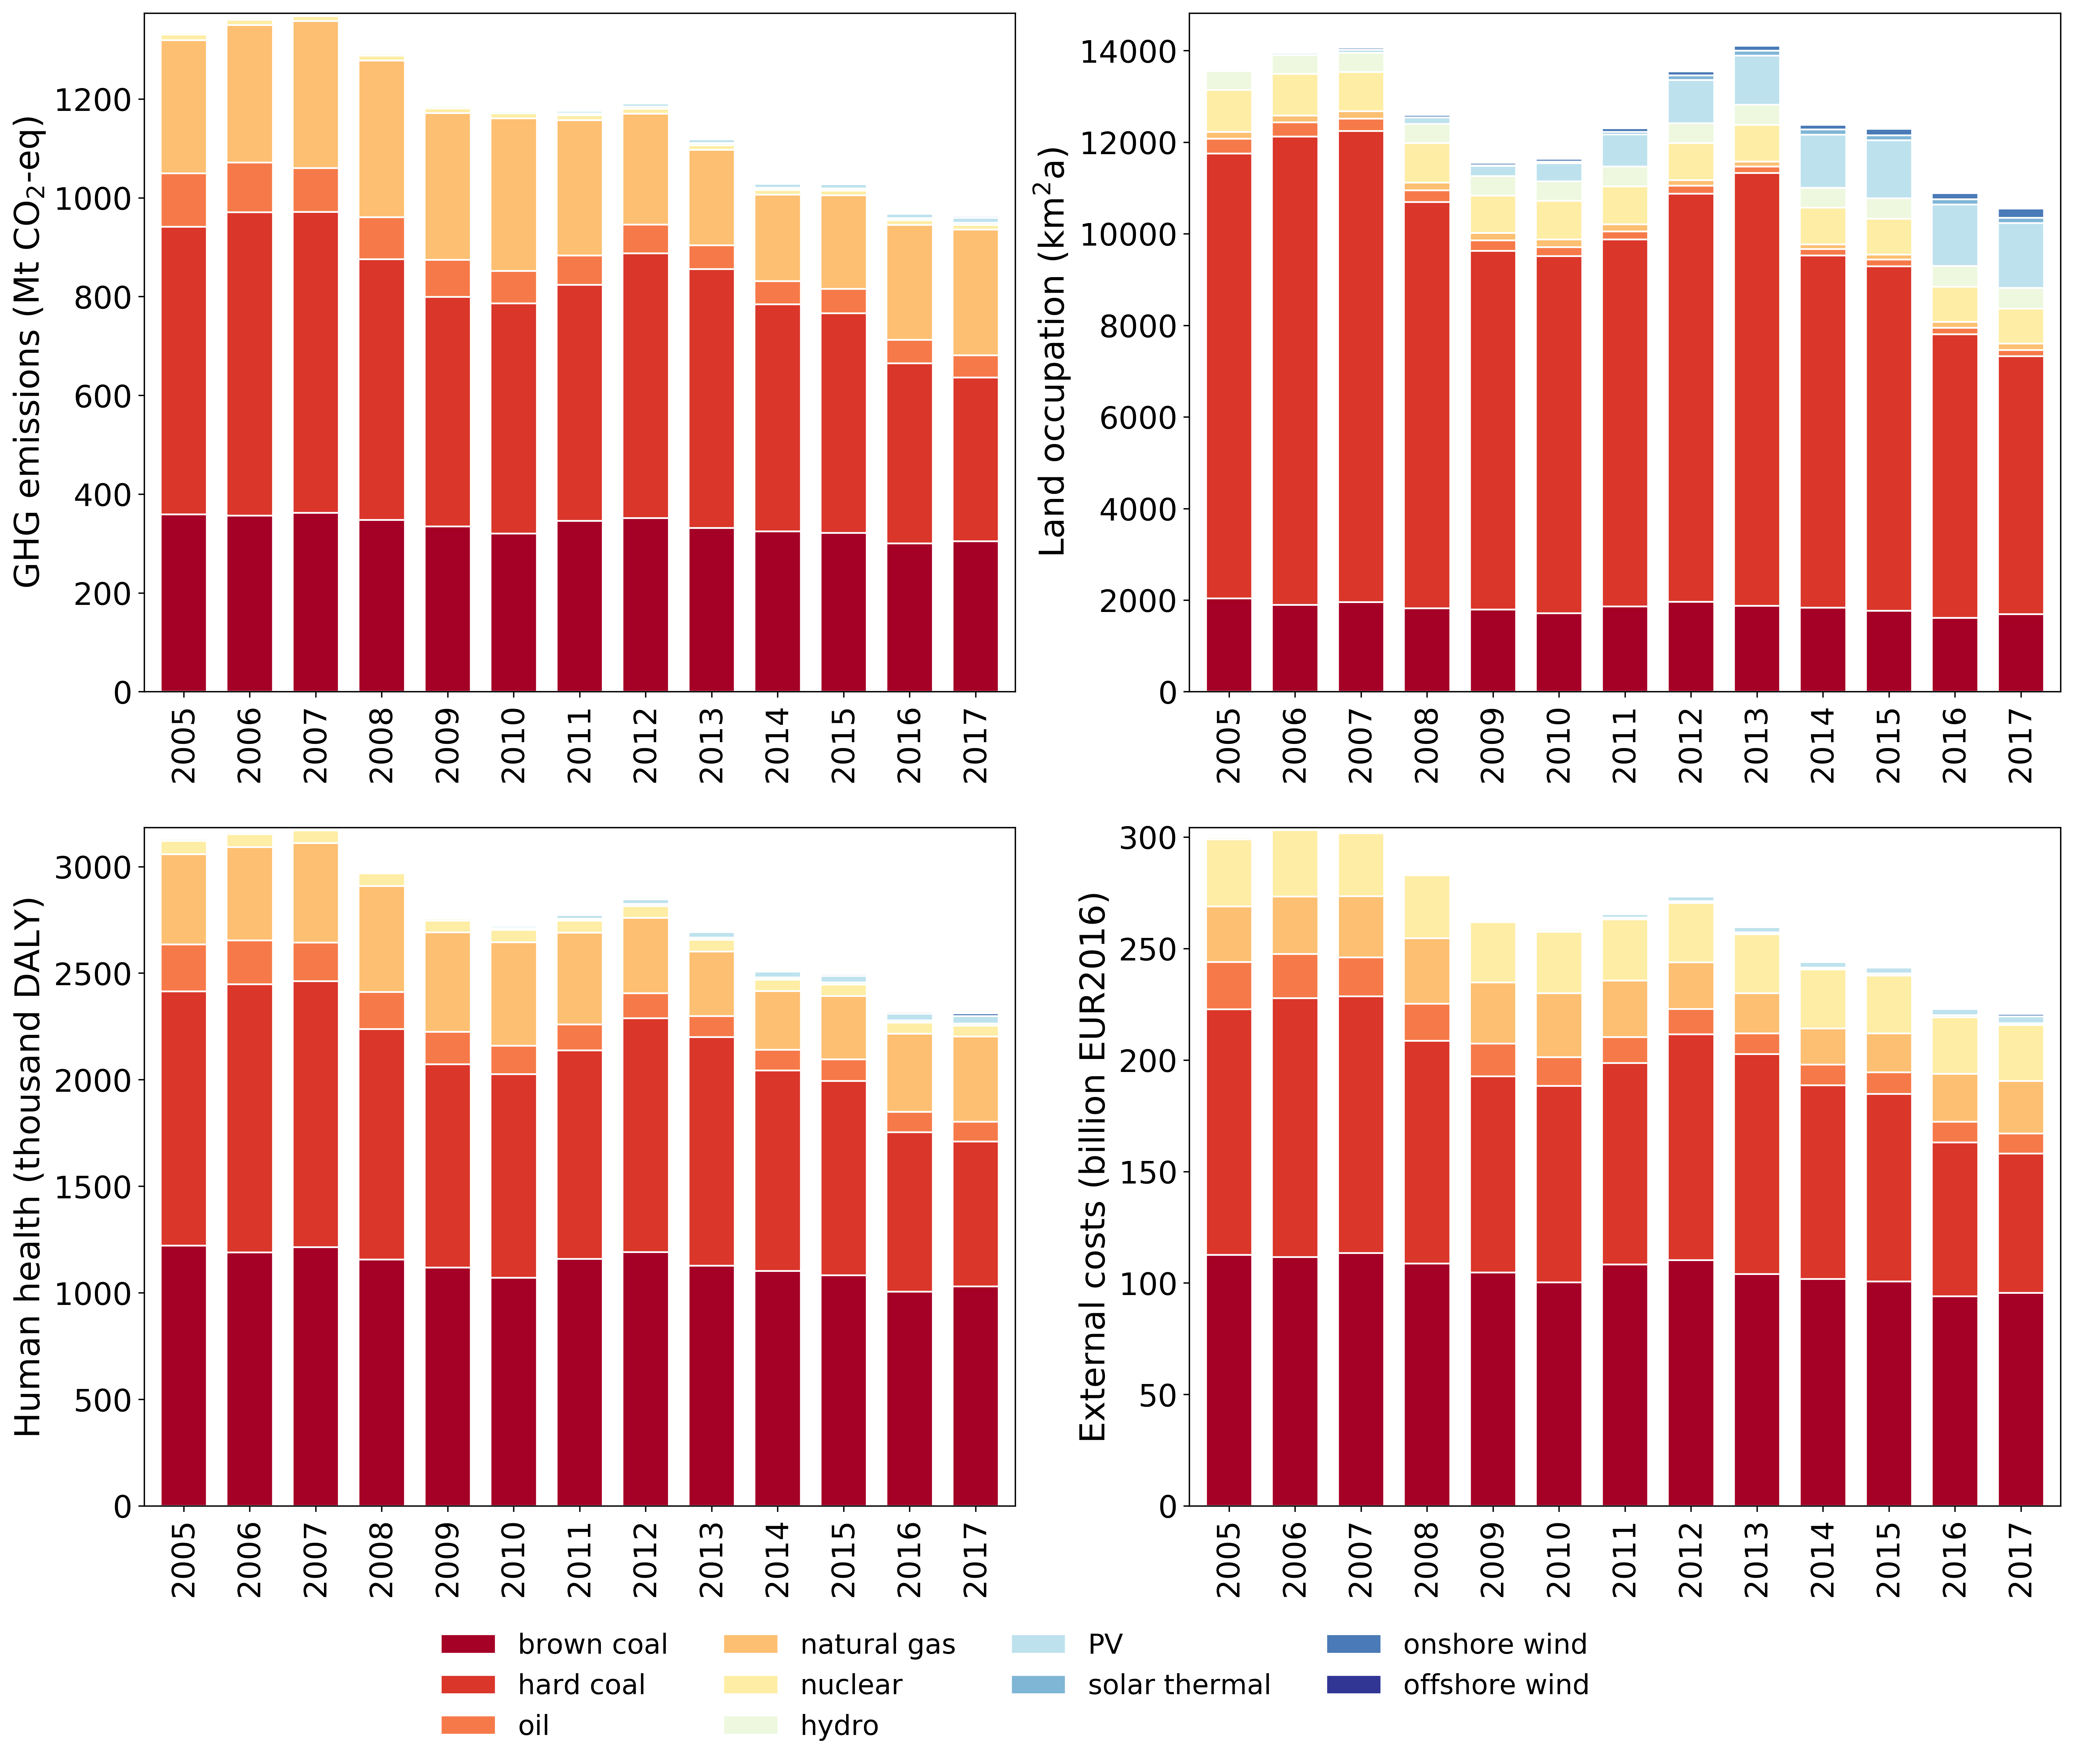

Figure 6: Annual life cycle impacts associated with electricity production in the EU28.

## Avoided impacts relative to 2005

The following section estimates the effect of increased use of renewable energy sources for electricity generation. The relative reductions in life cycle impacts are obtained by comparing the actual growth in use of renewable energy sources with a counterfactual scenario where this growth would have not taken place. Under this scenario, the assumption is that any growth in renewables would have been supplied by a mix of conventional sources and the difference between counterfactual and the actual data constitute a measure of ‘gross avoided impacts’.

### Effects at EU28 level

Figure 7 shows the difference between the counterfactual scenario and the actual life cycle impacts which correspond to renewable electricity generation at actual levels. This difference is also presented in Table 3. In 2017, avoided life cycle emissions of GHGs due to the increase of renewable electricity generation across the EU28 have amounted to almost 300 Mt CO2-eq annually. Cumulatively, over the period 2005-2017 total avoided emissions amount to 1691 Mt CO2-eq. Cumulative avoided impacts for the other indicators are respectively 7010 km2a, 3632 DALY, and 321 billion EUR2016. Note that GHG emissions, human health and environmental costs follow largely the same trends as the latter two are influenced to a large extent by GHG emissions. As would be expected the land occupation avoided impacts are lower due to the increase in land occupation associated with PV power.

Table 3: Estimated avoided impacts in the EU28.

|  |  |  |  |  |  |  |  |  |  |  |  |  |  |
| --- | --- | --- | --- | --- | --- | --- | --- | --- | --- | --- | --- | --- | --- |
|  | **2005** | **2006** | **2007** | **2008** | **2009** | **2010** | **2011** | **2012** | **2013** | **2014** | **2015** | **2016** | **2017** |
| *GHG emissions*  *(Mt CO2-eq)* | 0 | -22 | -36 | -48 | -60 | -98 | -108 | -140 | -192 | -205 | -234 | -258 | -290 |
| *Land occupation*  *(km2a)* | 0 | -209 | -311 | -332 | -334 | -509 | -280 | -322 | -840 | -737 | -884 | -1087 | -1165 |
| *Human health (DALY)* | 0 | -47 | -79 | -101 | -126 | -206 | -227 | -298 | -410 | -439 | -507 | -549 | -643 |
| *External costs (billion EUR2016)* | 0 | -42 | -71 | -90 | -111 | -181 | -203 | -264 | -361 | -389 | -449 | -486 | -567 |

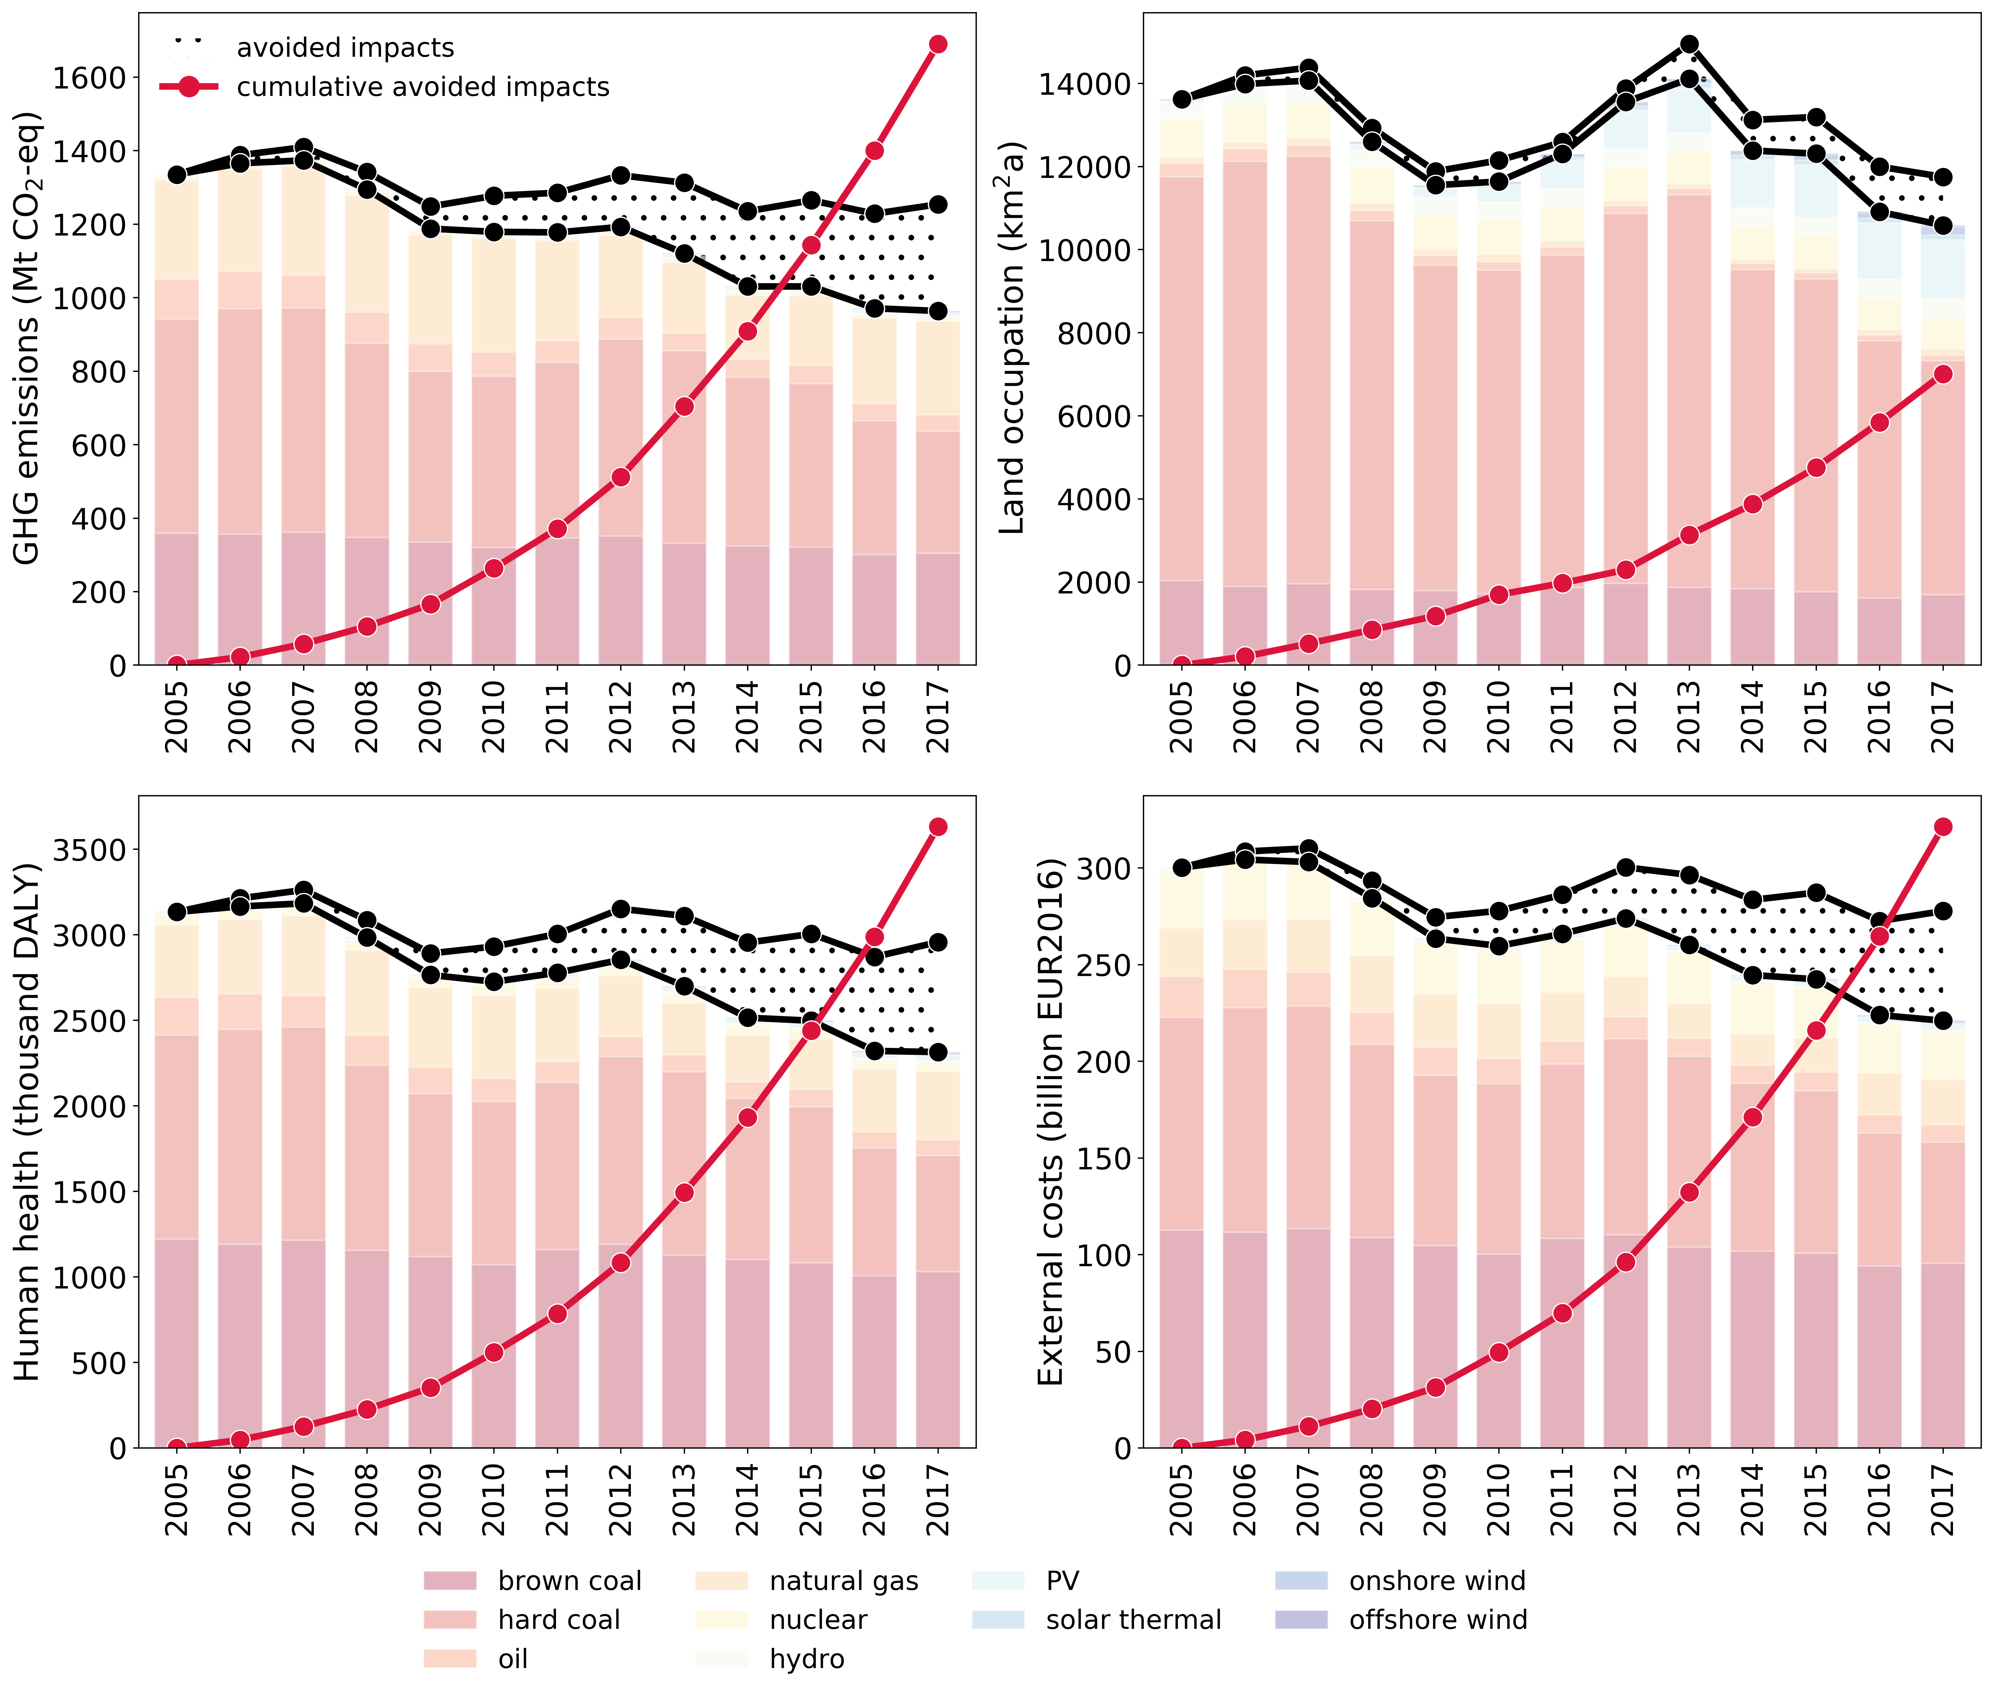

Figure 7: Avoided annual life cycle impacts and cumulative avoided impacts.

# Discussion

This report summarises findings regarding the avoided impacts, from a life cycle perspective, due to increased use of RES in electricity generation. Methodological uncertainties are discussed briefly in this chapter and in more detail in Section 3 of the methodology report (Bouman 2019). A comparison with similar estimates from previous studies is presented, along with general recommendations for future iterations.

## Methodological uncertainty

One of the largest challenges in this exercise is to find a way to correctly represent the energy balance for each electricity generation technology, while keeping the amount of life cycle inventories manageable. This was achieved in this report by effectively parameterizing the LCI models, i.e. through adjusting key parameters is an archetypical model of the technology. However, a one-to-one correspondence between the energy input data, which is available at a high level of detail, and the life cycle inventories, does not exist. For example, the category ‘hard coal’ comprises three different types of coal in the Eurostat energy balances (i.e. anthracite, coking coal, and other bituminous coal) and a potential 4 different generators, namely the generation of electricity only or co-generation of heat and power as main activity producer or as autoproducer. While emissions factors for each of these feedstocks may be available, an extensive literature search was outside the scope of this report and default emissions factors for hard coal from readily available emission inventory guidelines were used instead. The aggregation also implies that there is no differentiation between upstream emissions associated with, for example, either anthracite or coking coal.

While the limited number of inventories provided over 90% coverage in terms of electricity production, not all electricity generation technologies are represented in the model, most notably electricity generation for peat and peat products and generation from oil shale and oil sands. While this does not influence the avoided GHG emissions at aggregate level, this may influence the national results for those Member States relying heavily on either of these fuel products, such as Estonia. This also implies that the share of renewable energy sources in the electricity presented in Figure 5 may be overestimated, reflecting only the mix that can be assessed in the model.

## Recommendations for future updates

Future recommendations are to include extra life cycle inventories for peat combustion and generation of electricity from oil shale, in order to increase the sectoral coverage of electricity production. In addition, there is potential for refinement of all base LCI models, based on a wider literature search. This is particularly valid of the inventories relying on biologically derived feedstock.

From a methodological perspective, it should be noted that life cycle impacts are calculated by collapsing the time dimension. In reality, the construction of, operation and decommissioning of power plants takes place over many decades and in a rapidly changing energy system impacts associated with production of (old and new) power generation capacity may vary based on power plant vintage. However, the construction of a European wide vintage stock model of electricity generation capacity requires significant efforts, beyond the scope of this task.

# Conclusions

In this report, we calculate estimates for the avoided environmental impacts associated with the increased use of RES for electricity production in the EU28. Based on a set of life cycle inventories, life cycle impact assessment results were calculated per unit of electricity generated by each of the key technologies assessed, per Member State and for each year in the time period 2005-2017. These results were subsequently scaled up to produce an estimate of life cycle greenhouse gas emissions at EU28 aggregate level. Through comparison with a counterfactual scenario, an estimate of avoided environmental impacts from life cycle perspective was obtained.

Results show that the increasing introduction of electricity generated from renewable sources has decreased GHG emissions significantly in the period 2005-2017. Annual avoided GHG emissions were estimated to be in excess of 300 Mt CO2-eq, which is larger than the total annual greenhouse gas emissions without land use, land use change and forestry of almost two-thirds of the EU28 member states. Cumulatively, avoided GHG emissions amounted to approximately 1800 Mt CO2-eq. At Member State level, the UK had the largest avoided emissions due to introduction of a significant amount of on- and offshore wind power as well as solar photovoltaic power.

In addition to an estimation of life cycle GHG emissions, five other impact indicators (eutrophication, particulate matter formation, acidification, freshwater ecotoxicity and land occupation) were quantified. Except for freshwater ecotoxicity, a downward trend was observed for all impact indicators, highlighting the co-benefits of increased generation from renewable energy sources.

A large part of emissions reduction can be attributed to the phase out of hard coal power plants in favour of renewable and natural gas generation technologies. In addition, electricity generation from oil has decreased. However, the combustion of brown coal has remained relatively constant over the period 2005-2017. This has led to the situation that the contributions of brown coal, hard coal and natural gas to GHG emissions from electricity production are approximately equal. As the combustion of brown coal results in the highest GHG emissions per unit of electricity generation, there are significant potential gains associated with focusing on its phase out.

# References

Bouman, E. A. (2019). A life cycle perspective on benefits of renewable electricity generation - Methodology and assumptions, ETC/CME

EEA, European Environment Agency (2015). Renewable energy in Europe - approximated recent growth and knock-on effects. M. Tomescu, I. Moorkens, W. Wetzels, L. Emele and H. Förster. Copenhagen.

EEA, European Environment Agency (2018). Renewable energy in Europe - Recent growth and knock-on effects. A. Das, L. Emele, F. Meinke-Hubeny et al. Copenhagen.

EEA, European Environment Agency. (2019). "EEA greenhouse gas - data viewer." Retrieved Oct 28, 2019, from <https://www.eea.europa.eu/data-and-maps/data/data-viewers/greenhouse-gases-viewer>.

EMEP and EEA (2016). EMEP/EEA air pollutant emission inventory guidebook 2016: Technical guidance to prepare national emission inventories.

Hertwich, E. G., T. Gibon, E. A. Bouman, A. Arvesen, S. Suh, G. A. Heath, J. D. Bergesen, A. Ramirez, M. I. Vega and L. Shi (2015). "Integrated life-cycle assessment of electricity-supply scenarios confirms global environmental benefit of low-carbon technologies." Proceedings of the National Academy of Sciences **112**(20): 6277-6282.

IPCC (2006). 2006 IPCC Guidelines for National Greenhouse Gas Inventories. H. S. Eggleston, L. Buendia, K. Miwa, T. Ngara and K. Tanabe. Japan.

ISO (2006). ISO 14044:2006: Environmental Management - Life Cycle Assessment - Requirements and Guidelines. Geneva, Switzerland, International Organization for Standardization.

UNEP, United Nations Environment Programme (2016). Green Energy Choices: The benefits, risks and trade-offs of low-carbon technologies for electricity production. Paris, United Nations Environment Programme.

# Zotero references.

EC. 2015. Communication from the Commission to the European Parliament, the Council, the European Economic and Social Committee, the Committee of the Regions and the European Investment Bank — A Framework Strategy for a Resilient Energy Union with a Forward-Looking Climate Change Policy. COM(2015) 80 Final. https://eur-lex.europa.eu/legal-content/EN/TXT/?uri=CELEX:52015DC0080.

EEA. 2015. “Renewable Energy in Europe — Approximated Recent Growth and Knock-on Effects.” EEA Technical Report 1/2015. European Environment Agency. http://www.eea.europa.eu/publications/renewable-energy-in-europe-approximated.

———. 2017. “Analysis of Key Trends and Drivers in Greenhouse Gas Emissions in the EU between 1990 and 2015.” EEA Report 8/2017. https://www.eea.europa.eu/publications/analysis-of-key-trends-and.

———. 2018. “Trends and Drivers in Greenhouse Gas Emissions in the EU in 2016.” Briefing No 5/2018. European Environmental Agency. https://www.eea.europa.eu/publications/trends-and-drivers-in-greenhouse.

———. 2019. “EEA Greenhouse Gas — Data Viewer.” European Environment Agency. 2019. http://www.eea.europa.eu/data-and-maps/data/data-viewers/greenhouse-gases-viewer.

EU. 2009. Directive 2009/28/EC of the European Parliament and of the Council of 23 April 2009 on the Promotion of the Use of Energy from Renewable Sources and Amending and Subsequently Repealing Directives 2001/77/EC and 2003/30/EC. OJ L 140, 5.6.2009, p. 16-62. https://eur-lex.europa.eu/legal-content/EN/TXT/PDF/?uri=CELEX:32009L0028&from=DE.

# Annex 1 Implemented emissions factors for fuel combustion

The table below shows the implemented emissions factors for the combustion of fuels.

Table 4: Emissions factors for different fuels.

|  |  |  |  |  |  |  |
| --- | --- | --- | --- | --- | --- | --- |
| **Pollutants** | **Brown coal** | **Hard coal** | **Oil** | **Natural gas** | **Unit** | **Reference** |
| *CO2* | 1.01E+02 | 9.83E+01 | 7.74E+01 | 5.61E+01 | kg/GJ | IPCC, 2006 |
| *CH4* | 1.00E-03 | 1.00E-03 | 1.00E-03 | 1.00E-03 | kg/GJ | IPCC, 2006 |
| *N2O* | 1.50E-03 | 1.50E-03 | 6.00E-04 | 1.00E-04 | kg/GJ | IPCC, 2006 |
| *As* | 1.43E-05 | 7.10E-06 | 4.27E-06 | 1.20E-07 | kg/GJ | EMEP/EEA, 2016 |
| *Benzo(a)pyrene* | 1.30E-09 | 7.40E-10 | - | 5.62E-10 | kg/GJ | EMEP/EEA, 2016 |
| *Cd* | 1.80E-06 | 9.00E-07 | 1.29E-06 | 2.50E-10 | kg/GJ | EMEP/EEA, 2016 |
| *CO* | 8.70E-03 | 8.70E-03 | 5.00E-03 | 3.93E-02 | kg/GJ | EMEP/EEA, 2016 |
| *Cr* | 9.10E-06 | 4.50E-06 | 2.73E-06 | 7.60E-10 | kg/GJ | EMEP/EEA, 2016 |
| *Cu* | 1.00E-06 | 7.80E-06 | 5.69E-06 | 7.60E-11 | kg/GJ | EMEP/EEA, 2016 |
| *HCB* | 6.70E-09 | 6.70E-09 | - | - | kg/GJ | EMEP/EEA, 2016 |
| *Hg* | 2.90E-06 | 1.40E-06 | 3.70E-07 | 1.00E-07 | kg/GJ | EMEP/EEA, 2016 |
| *Ni* | 9.70E-06 | 4.90E-06 | 2.73E-04 | 5.10E-10 | kg/GJ | EMEP/EEA, 2016 |
| *non methane VOCs* | 1.40E-03 | 1.00E-03 | 8.00E-04 | 2.60E-03 | kg/GJ | EMEP/EEA, 2016 |
| *NOx* | 2.47E-01 | 2.09E-01 | 1.42E-01 | 8.90E-02 | kg/GJ | EMEP/EEA, 2016 |
| *Pb* | 1.50E-05 | 7.30E-06 | 4.88E-06 | 1.50E-09 | kg/GJ | EMEP/EEA, 2016 |
| *Particulates* | 1.11E-02 | 1.11E-02 | 4.45E-02 | 1.78E-03 | kg/GJ | EMEP/EEA, 2016 |
| *Se* | 4.50E-05 | 2.30E-05 | 2.21E-06 | 1.12E-08 | kg/GJ | EMEP/EEA, 2016 |
| *SOx* | 1.68E+00 | 8.20E-01 | 4.95E-01 | 2.81E-04 | kg/GJ | EMEP/EEA, 2016 |
| *Zn* | 8.80E-06 | 1.90E-05 | 9.41E-05 | 1.50E-09 | kg/GJ | EMEP/EEA, 2016 |



European Topic Centre on Climate change mitigation and energy

Boeretang 200

B-2400 Mol, Belgium

Tel.: +32 14 33 59 77

Email: etccme@vito.be

The European Topic Centre on Climate change mitigation and energy (ETC/CME) is a consortium of European institutes under contract of the European Environment Agency.

1. Life cycle and upstream emissions, such as related to land use, land use change and forestry (LULUCF) due to the sourcing of biomass resources, are not taken into account in that methodology.
2. In the case of electricity generation, LCA models typically adopt a ‘cradle-to-gate’ approach, i.e. environmental impact indicators are calculated per unit of electricity delivered to the grid. Impacts associated with transmission infrastructure, transmission losses, as well as impacts associated with the use of the electricity are omitted.
3. Data from Eurostat table *nrg_bal_c*. Used are the indicators Gross Electricity Production and Transformation Input. For a full overview see section 2.3 in *Bouman, E. A. (2019). A life cycle perspective on benefits of renewable electricity generation - Methodology and assumptions, ETC/CME* 
4. A public version is available here: <https://ec.europa.eu/eurostat/web/energy/data/shares>